  - Strategic Plan for FY 2020-2021 Hillsborough School District

TAble of
Contents
Statement of purpose ……………..2
Environmental Scan………………………………………………………………………………3
(SWOT)…………………………………………………………………………………………3
Vision Statement 3
Mission Statement 2 …………...4

Goals and Objectives/Action Plan ………………………………………………………………………………………………5

Action Plan…………………………………………………………………………………………5

Budget/Resources……………………………………………………………………………6

Policies and Procedures……………………………………………………………………………………7

Next Steps……………………………………………………………………………………8

Statement of Purpose

Young Middle Magnet Media Center is a library in an urban public school in the heart of the city of Tampa Bay, Florida, serving approximately 650 students. With 95% free and reduced lunch and 91% minority student body makeup, Young Middle Magnet School has maintained a C school grade based upon Florida’s state school grading criteria scale of A-F. As a Creative Science center and STEM (Science, Technology, Engineering and Mathematical) hub, the library supports the academic needs of sixth, seventh and eighth grade students. The media center is home to a Computer Science section, a Lego Spike lab and Cubelet’s to support students in their endeavors to meet curriculum goals tied to understanding the place of global sustainability and engineering within the world around them.
Values that guide the work of YMM Media Staff
Collaboration - We will work as a cohesive team and be creative in our approach to teaching
and learning
- We encourage cooperation with other individuals in the community
- We recognize that community support is vital to our mission

Inclusiveness - We will embrace diversity and create equitable learning and work environments.
• We work together to serve the interests of all people.
• We value our school’s diversity and reflect that diversity in our lessons, events and collection.
• We strive to make all users feel welcomed.

Respect – Every person is worthy of respect and dignity
- We provide the highest quality services possible with the resources available.
- We strive to tailor services to individual needs.
- We pledge to maintain privacy and confidentiality.
- We treat all people fairly.

Environmental Scan

According to school survey, data the following strengths, weaknesses, opportunities and threats were revealed within the library program offered to students and staff within the past year. Prior to this, all Language Arts classes had biweekly visits to the media center for lessons, Reading classes used the media lab weekly and other content areas brought students quarterly for project lessons or book checkout.

Development of a School Literacy Committee

- In 2019 a school literacy committee was established for the purpose of building a school community of readers and focus on issues of literacy instruction and curriculum.
- The school literacy committee includes the Reading Coach, English Language Arts Subject Area Leader, School Administrator, English Speakers of Other Languages (ESL/ELL) Assistant and School Psychologist.
- Committee goals are to increase visibility and motivation for reading, ensure intensive interventions are provided in reading, and support academic and literacy development school-wide regardless of content area.

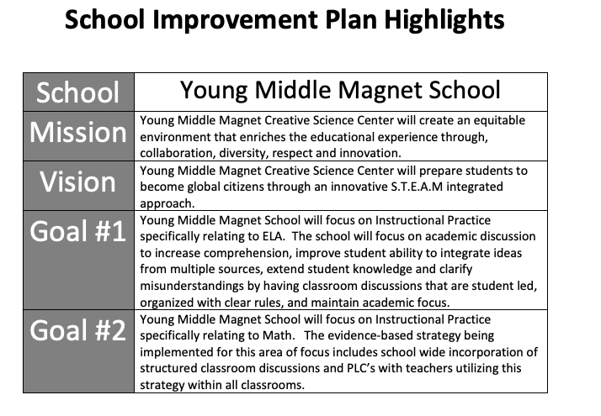

Young Middle Magnet Media Center Vision Statement

YMM Media Center will contribute positively to the growth and success of STEM through embedding STEM based reading and technology learning opportunities for student’s academic knowledge and achievement in STEM.

Young Middle Magnet Media Center Mission Statement

YMM Media Center will provide STEM related materials in books/literature and technology- based tools through hands on/minds on tasks to assist students in meeting STEM based and Project Lead the Way learning tasks for successful academic endeavors.

Goals and Objectives

Goal 1: Create a high-quality user experience in physical and online library spaces.

Objective: Increase student/teacher engagement in reading, library research and informational literacy.
Action Plan
- Media Specialist makes it easier to access a variety of programs, services and the collection for physical and online users.
- Create a reliable, intuitive and seamless online connection to resources.
- Improve library communication and messaging for clarity.

Goal 2: Media Specialist increases awareness of resources and services and communicate the value of the library through marketing efforts geared towards middle school teachers and teens with an interest in STEM.
Objective: To increase visibility throughout the school and community
Action Plan

- Create visual and visible entertaining STEM related advertisements and displays.
- Pilot new methods for highlighting newly acquired STEM texts and online programs.
- Create a space to highlight STEAM Club meetings, events and projects etc.
- Strengthen and formalize existing partner relationships (public lib, poets, etc.)
- Establish partnerships that reach new audiences.

Goal 3: Demonstrate a commitment to equity, diversity and inclusivity.

Objective: Offer programs, services and resources that celebrate our community’s diversity.
Action Plan

- Invite an author, speaker or performer to collaborate with students on a literacy project.
- Collaborate with teachers or community members to create (3) events focused on culture, diversity, inclusivity, etc.
- Host an event sponsored by the ELL program, whether a book club, conversation club, etc.

Budget/Resources

Operating Income | 2020 Actual | 2021  Budget | 1st 6 months 2021 | 2021 year end actual | 2022  Budget Request
Municipality | $ 50,000 | $ 52,000 | $ 52,000 | $ 52,000 | $ 55,050
County | $ 24,240 | $ 25,630 | $ 25,630 | $ 25,630 | $ 27,040
State / library system | $ 950 | $ 950 | $ 950 | $ 950 | $ 1,050
Federal (LSTA) | $ 550 | $ 800 | $ 385 | $ 800 | $ 2,000
Funds carried forward | $ 0 | $ 600 | $ 500 | $ 600 | $ 525
Fines | $ 700 | $ 900 | $ 390 | $ 900 | $ 945
Donations | $ 500 | $ 500 | $ 360 | $ 500 | $ 500
Fees/other | $ 100 | $ 100 | $ 45 | $ 100 | $ 105
Transfer from gift fund | $ 500 | $ 500 | $ 0 | $ 500 | $ 525
Operating Income Total | $ 77,540 | $ 81,980 | $ 80,260 | $ 81,980 | $ 87,740
Operating Expenditures | 2020 Actual | 2021  Budget | 1st 6 months 2021 | 2021 year end actual | 2022  Budget Request
Salaries and wages | $ 33,500 | $ 35,000 | $ 17,500 | $ 35,000 | $ 36,500
Employee benefits | $ 20,100 | $ 21,000 | $ 10,500 | $ 21,000 | $ 23,725
Books | $ 7,640 | $ 7,990 | $ 5,020 | $ 7,990 | $ 8,570
Periodicals | $ 1,500 | $ 1,600 | $ 750 | $ 1,600 | $ 1,785
Video materials | $ 1,200 | $ 1,200 | $ 725 | $ 1,200 | $ 1,350
Audio materials | $ 450 | $ 450 | $ 300 | $ 450 | $ 500
Software and electronic  material | $ 550 | $ 575 | $ 450 | $ 575 | $ 625
Contracted services | $ 1,100 | $ 1,200 | $ 575 | $ 1,200 | $ 1,325
Staff, board continuing education. | $ 1,300 | $ 1,325 | $ 655 | $ 1,325 | $ 1,400
Public programs | $ 600 | $ 550 | $ 300 | $ 550 | $ 600
Telecommunications | $ 2,000 | $ 2,500 | $ 1,200 | $ 2,500 | $ 2,585
Utilities | $ 5,000 | $ 5,300 | $ 2,800 | $ 5,300 | $ 5,325
Equipment repair | $ 600 | $ 700 | $ 300 | $ 700 | $ 825
Supplies | $ 2,000 | $ 2,500 | $ 1,000 | $ 2,500 | $ 2,625
Operating Expenditures Total | $ 77,540 | $ 81,890 | $ 42,075 | $ 81,890 | $ 87,740
Capital Income | 2009 Actual | 2010 Budget |  |  | 2011 Budget Request
Municipality | $ 2,500 | $ 4,000 |  |  | $ 4,000
Capital Expenditures | 2009  Actual | 2010  Budget |  |  | 2011  Budget Request
Equipment replacement | $ 2,500 | $ 3,000 |  |  | $ 4,000
New shelving |  | $ 1,000
Capital Expenditures Total | $ 2,500 | $ 4,000 |  |  | $ 4,000
Grand Total of ALL Expenditures (Operating + Capital) | $ 80,040 | $ 85,890 |  |  | $ 91,740
Adapted from Administrative Essential #13 DLTCL PLD
http://dpi.wi.gov/pld/ae13.html

Policies/Procedures
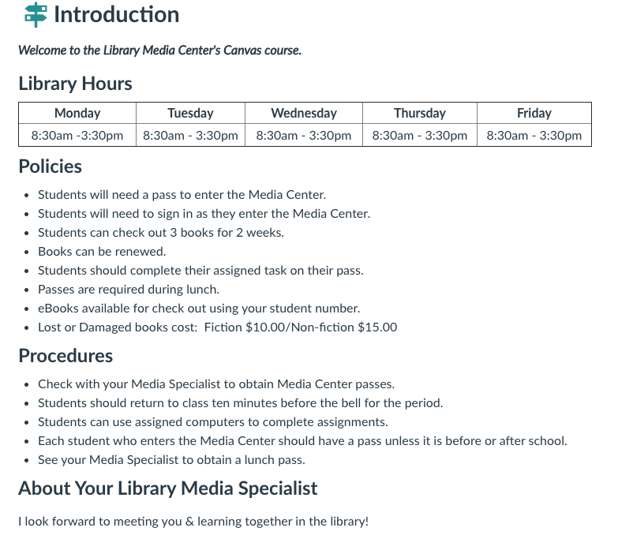

Next Steps (Implementation/Evaluation)

