LCSH and AAT Use of Controlled Vocabularies

Mitzi Mack
University of South Florida
Organization of Knowledge LIS 6711
July 24, 2020

Abstract
The Library of Congress Subject Headings and the Art and Architecture Thesaurus both use controlled vocabularies, what are some differences the two share?
Keywords: controlled vocabulary

Table of Contents
LCSH and AAT Use of Controlled Vocabularies 4
References 10

LCSH and AAT Use of Controlled Vocabularies
(Heyman, 2018)As a scholar in the field of library of science, much esteem is venerated to Nathan Ranganathan’s Five Laws by realizing the onus of the fifth law. The library is a growing organism, and as such, users need a language by which it is accessible and sustainable. Since, libraries live through a collection of resources, this system of organization must be sharable, comprehensible, yet specific. The Library of Congress Subject Headings (LCSH) and the Art and Architecture Thesaurus (AAT) both share an organized information system for access and sustainability across resource mediums yet, have varying differences defining their worth in the field.
For over one hundred years, the library and information world grew through the use of the Library of Congress Subject Headings as an organizational system creating access and sustainability (Chan, 1995). LCSH was developed with a universal standard controlled vocabulary (Ferris, 2009). Indexers and catalogers know all too well, the importance of defining the parameters of a database management system. Within the library of science field, a controlled vocabulary or a system of consistency with words is often used to set limits (McCutcheon, 2009). A controlled vocabulary can be used to list document types, describe relationships or things if it is considered linked data and can be used for retrieval (Heyman, 2018). Alphabetical lists, taxonomies, thesauri and ontologies are a few ways controlled vocabularies can be represented. Developing such a list, is a layered system as one determines the terminology, considers the format or structure as it is derived from content or context and finally, provides maintenance and support (Heyman). LCSH’s use of a controlled vocabulary made it a strong subject access tool, so much so, that Art and Architecture Thesaurus used it as its foundation during implementation (Ferris). Though LCSH was strong as a keyword search tool, it’s syntax could be complex and worked best from literal scientific terms (Stam). On the other hand, AAT required a tool that could provide specific searches for related terminology (Whitehead, 1989). Hence, the varying differences in considering LCSH from a literal perspective while viewing AAT through a figurative lens.
Library of Congress Subject Headings became the designated system for Library of Congress’ holdings once it was moved from the capital (Chan). The basis for its longevity was the fact that its foundation was a standard, controlled vocabulary and had history with bibliographic work (Ferris, 2008). Using keyword search with precoordinated terms from a rich vocabulary, was a strength to the LCSH. Many of its searched properties were literal in the sense of scientific terms or features. For example, LCSH terms tell what something is about or what it actually is, as in its form (McCutcheon, 2009). An example of this would best be represented by listing nouns such as mosque, plans, etc. (Stam, 1991). LCSH was not without its disadvantages. Take for instance it’s language bias and changes that took place strictly due to this issue, as in changing aliens to noncitizens and removing the term illegal aliens altogether from the vocabulary per requests (Ferris). LCSH worked well in its original card catalog format for years, but the complexities rendered the need for a version with a simpler syntax. Based on this premise, LCSH implemented a change to FAST ensuring automatic retrieval, simplicity and interoperability (O’Neill and Chan, 2003).
The Art and Architecture Thesaurus (AAT) developed in 1990 after ten years in the making, used the Library of Congress Subject Headings as a foundation but modified it’s use (Petersen, 1995). The purpose of the AAT was to offer a method of indexing art and architecture resources (Carmin, 1991). Part of understanding this responsibility was identifying the forms of the art and architecture, which was quite diverse. In its first three volume edition the AAT was complicated as a search tool and difficult to update (Pratt, 2008). When applied to specific content area, as is the case for AAT, the breadth and depth of the search would be expansive from a figurative perspective. J. Paul Getty Trust served as the overseer on this project and consulted a team of technologists to create a system by which terms could be searched based on the individual having little knowledge of the content area. Operating as a thesaurus, one word would be selected as the preferred synonym, and others would be eliminated or placed in categories hierarchically (Dykstra, 1989). According to Carmine (1991) this organization was considered facets, in which the terms shared characteristics. These facets were related to schema in art and architecture disciplines and ranged from abstract to concrete (Whitehead). Out of the seven facets, the objects facet held the largest number of terms. The system was designed to employ subject analysis by using a classification level. In other words, single concepts could combine to create more complex concepts. For instance, in the following search for abstract and expressionism, only one result is garnered (see Figure 1 below). However, when searching for abstract or expressionism a host of results appears (see Figure 2 below). Disadvantages of the AAT has been its lack of illustrations for objects requiring visual representation, which also included iconographic analysis. Iconography was important when relating to slides, photos and digital political cartoons. The Categories for the Descriptions for the Works of Art group continues to discuss metadata schema to support the use of description in these examples to provide a more conclusive representation.
Keyword or subject searches in science and art can look very different. Though Library of Congress Subject Headings and Art and Architecture Thesaurus were both designed to take advantage of the subject access tool, they become very different entities when considering the content and context in which the search would take place. In scientific terms the search is largely fixated on the actual literal version of the word, however, in art, meanings of the object play a role in searching for the term. Take for example the art term ‘cabinet pictures’ which could be very different from ‘cabinets’ and ‘pictures (Whitehead)’. Meaning plays a key role in understanding which result to render, therefore, the AAT had to be designed to account for a single concept aided by a more complex concept. Another key difference between the two, was in the use of clarity as a strong factor when dealing with LCSH terms, as opposed to dealing with stylistic and poetic terms in the AAT (Stam). Terms focused on clarity could be maintained more economically and assisted through computer indexing systems (O’Neill & Chan), whereas, art history terms required interpretation and another level of classification. Ultimately, these differences were housed within the controlled vocabulary settings and was addressed in various ways through limits set on the criteria listed within set structures. Libraries and museums learned to move beyond subject analysis to conceptual analysis to be inclusive of the objects within their purview. While, LCSH continued to be strong and consistent in its delivery and accuracy in supporting library collections, it would still need to consider specific add-ons for special disciplines (McCutcheon).
Figure 1
Computer Search - Abstract and Expressionism
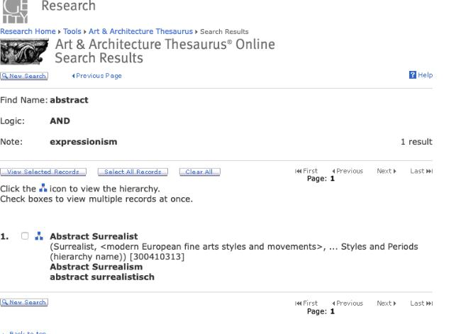

Figure 2
Computer search- Abstract OR Expressionism
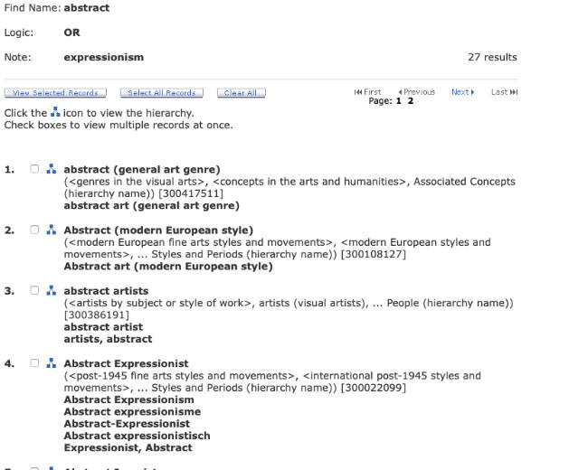

References
Dykstra, M. (1989). Subject analysis and thesauri: A background. Art Documentation: Journal of the Art Libraries Society of North America, 8(4), 173–174. https://doi.org/10.1086/adx.8.4.27948126
Ferris, A. M. (2018). Birth of a subject heading. Library Resources & Technical Services, 62(1), 16. https://doi.org/10.5860/lrts.62n1.16
Heyman, M. (2018). Keeping the beat: How controlled vocabularies affect indexing. The Indexer: The International Journal of Indexing, 36(4), 148–156. https://doi.org/10.3828/indexer.2018.59
Library of congress subject headings: Principles and applications. lois mai chan. (1980). The Library Quarterly, 50(1), 148–150. https://doi.org/10.1086/629884
Mary Pratt. (2008). Pratt, M. K. The Art of Cataloging Art. Computerworld, 42(11), 36–38..
McCutcheon, S. (2009). Keyword vs controlled vocabulary searching: The one with the most tools wins. The Indexer: The International Journal of Indexing, 27(2), 62–65. https://doi.org/10.3828/indexer.2009.21
O'Neill, E. T., & Mai Chan, L. (2003). Fast (faceted application of subject terminology): A simplified vocabulary based on the library of congress subject headings. IFLA Journal, 29(4), 336–342. https://doi.org/10.1177/034003520302900412
Petersen, T. (1990). Art & architecture thesaurus.. Oxford University Press.
Torre, D. S. (1995). Ksr: Keywording for subject retrieval. Art Documentation: Journal of the Art Libraries Society of North America, 14(2), 29–35. https://doi.org/10.1086/adx.14.2.27948730

